
SE-401L Human Computer Interaction Lab
Sir Dr. Hamid Ullah
23 April 2026
Ali Khan – 23MDSWE248
Visit Github
HCI Lab_08
University of Engineering and Technology Mardan

Target Users
- Students
- Gym users
- Beginners (no prior fitness experience)
- Busy professionals

Information Needed from Users
- Age group
- Gender (optional)
- Fitness level (beginner, intermediate, advanced)
- Health conditions (optional/sensitive)

Main Points to Understand
1. Fitness Goals
- Weight loss
- Muscle gain
- General fitness
- Flexibility
2. Daily Routine
- Available workout time
- Preferred workout time (morning/evening)
- Activity level
3. Problems / Pain Points
- Lack of motivation
- No proper guidance
- Time constraints
- Confusion about workouts
4. Preferences
- Home workout vs gym
- Video-based guidance or text
- Diet plans required or not
- Notifications/reminders preference

Consent Form for Fitness App Survey
Purpose:
This survey is being conducted as part of an HCI lab project to design a fitness application that better understands user needs and preferences.
Time Required:
The survey will take approximately 3–5 minutes to complete.
Privacy Statement:
All information collected will remain confidential and will only be used for academic purposes. No personal data will be shared with third parties.
Consent:
By continuing with this survey, you agree to participate voluntarily.

Section 1: Basic Information
- What is your age group?
  - Under 18 / 18–25 / 26–35 / 36+
- What is your gender? (Optional)
  - Male / Female / Prefer not to say

Section 2: Fitness Habits
- How often do you exercise?
  - Daily / 3–5 times a week / Rarely / Never
- Where do you prefer to work out?
  - Home / Gym / Outdoors
- How much time can you dedicate daily?
  - 15 min / 30 min / 1 hour / More

Section 3: Preferences & Opinions
- What is your main fitness goal?
  - Weight loss / Muscle gain / Stay fit / Other
- What features would you like in a fitness app?
  - Workout plans
  - Diet plans
  - Progress tracking
  - Reminders
  - Video tutorials
- Do you currently use any fitness app?
  - Yes / No
Open-Ended Question
- What problems do you face while maintaining your fitness routine?

Images:
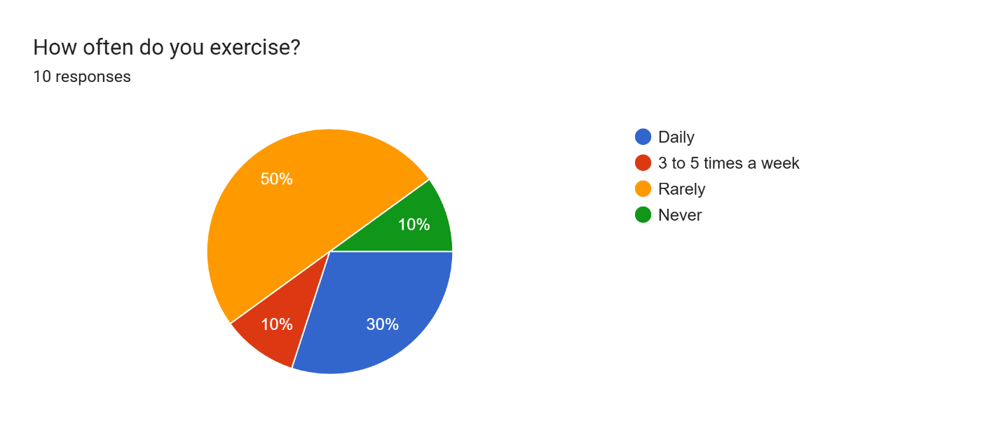
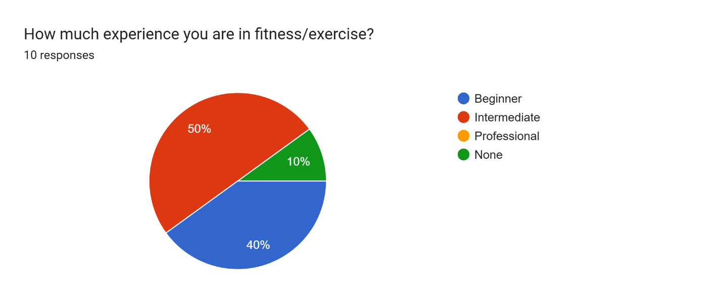
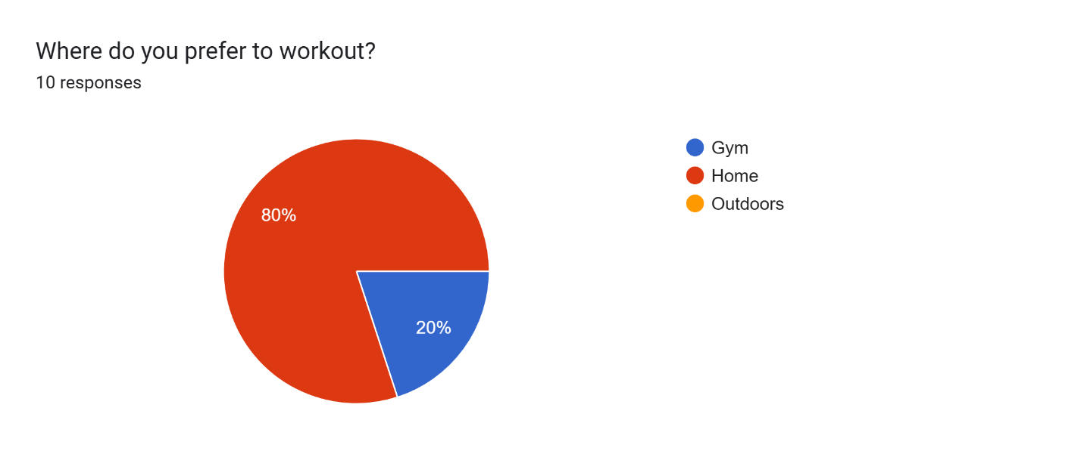
Summary:
Based on the survey data, users are looking for a comprehensive fitness app that primarily focuses on weight loss and muscle building through structured workout plans and progress tracking. Most respondents are currently exercising at a beginner to intermediate level and express a strong interest in integrated features like personalized diet plans and activity reminders to stay consistent. There is a clear demand for versatility, with users wanting a mix of gym-based and home-friendly routines that can be easily monitored. Ultimately, the ideal app would serve as a "one-stop shop" that simplifies fitness by combining exercise guidance with nutritional support and habit-forming tools.

